Group B

Perform the following data visualization operations using Tableau on Adult and Iris datasets.

a. 1D (Linear) Data visualization

b. 2D (Planar) Data Visualization

c. 3D (Volumetric) Data Visualization

d. Temporal Data Visualization

e. Multidimensional Data Visualization

f. Tree/ Hierarchical Data visualization

g. Network Data visualization

1. 1D (Linear) Data visualization of Adult Dataset

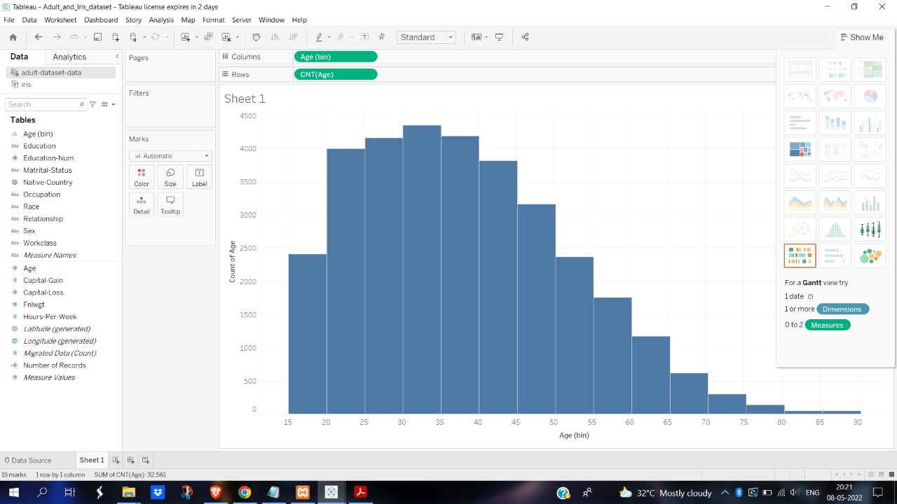

1. 2D (Planar) Data Visualization of Adult Dataset

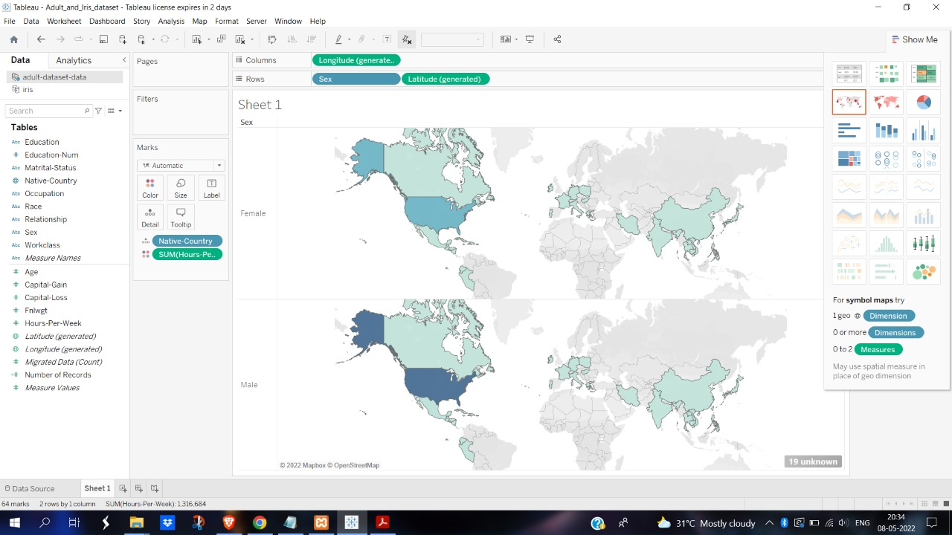

1. Temporal Data Visualization of Adult Dataset

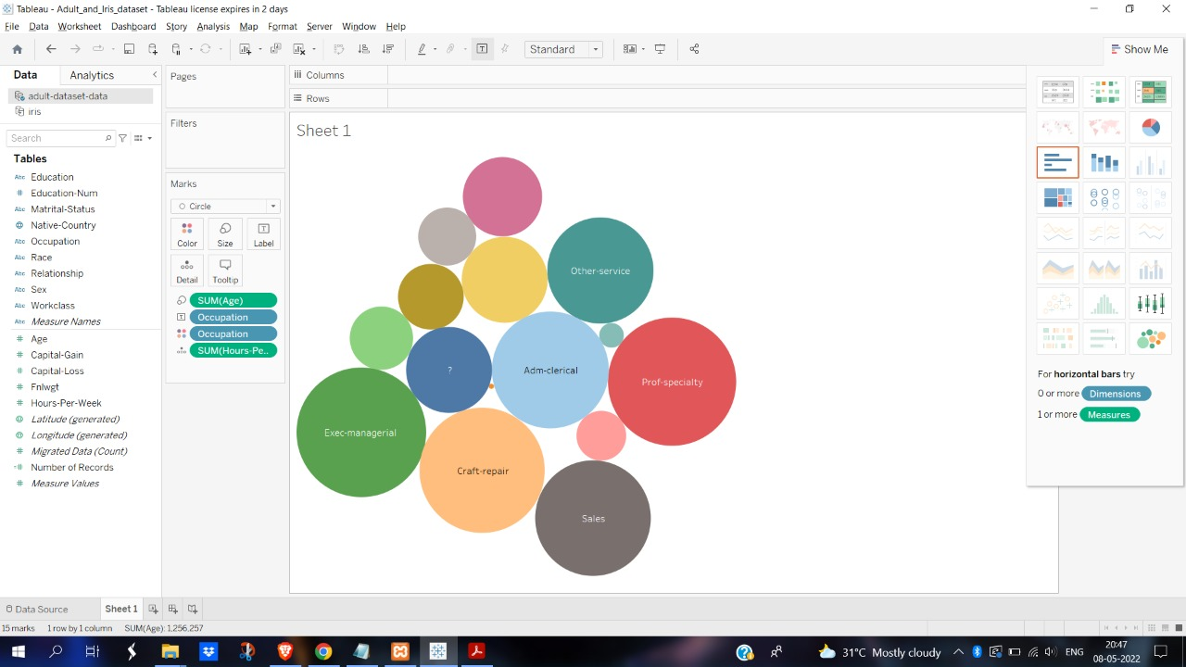

1. Multidimensional Data Visualization of Adult Dataset

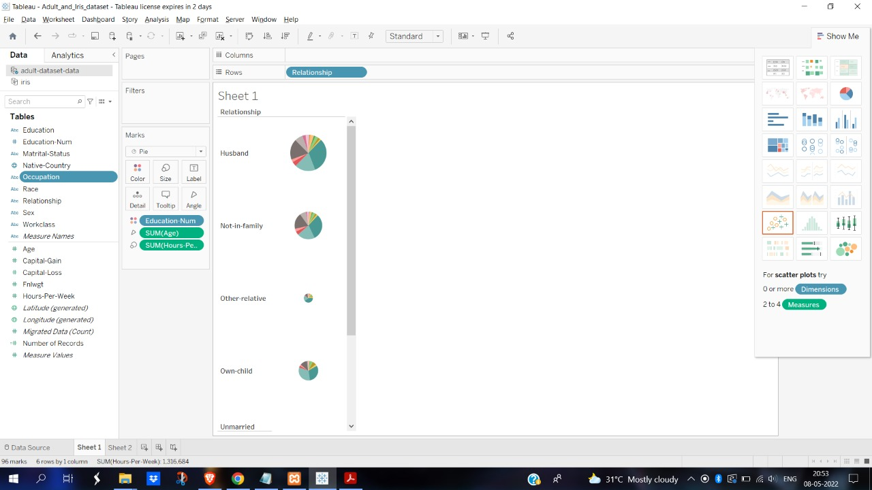

1. Tree/ Hierarchical Data visualization of Adult Dataset

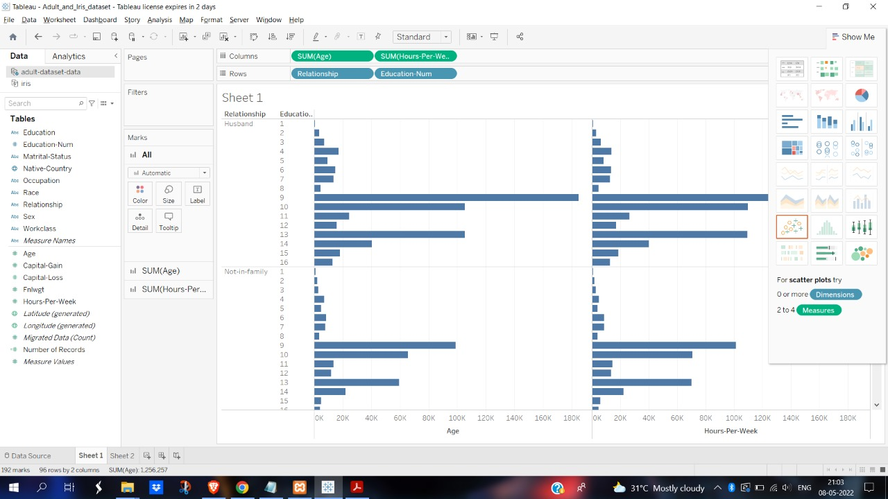

1. 1D (Linear) Data visualization of Iris Dataset

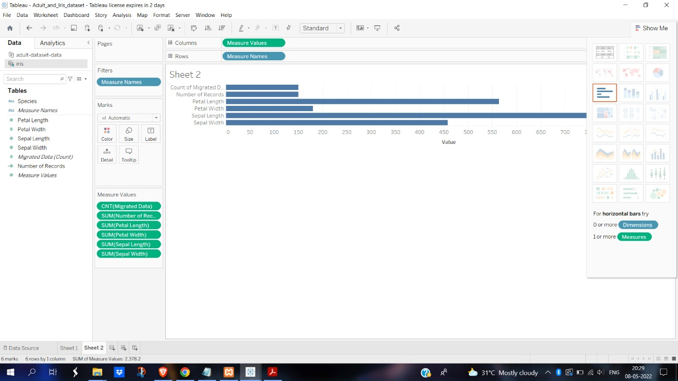

1. 2D (Planar) Data Visualization of Iris Dataset

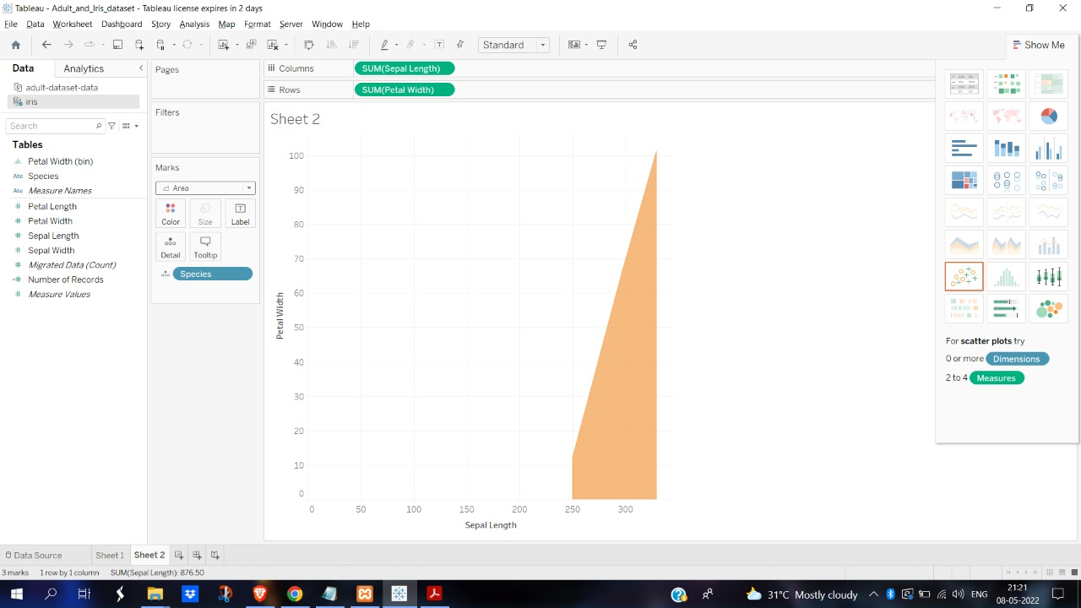

1. Temporal Data Visualization of Iris Dataset

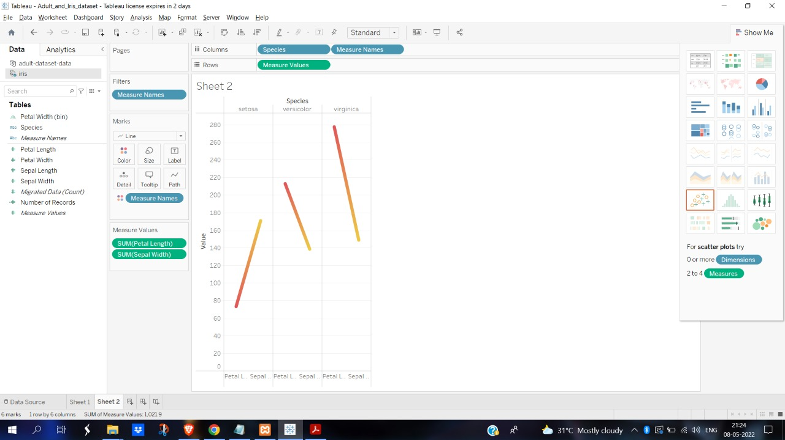

1. Multidimensional Data Visualization of Iris Dataset

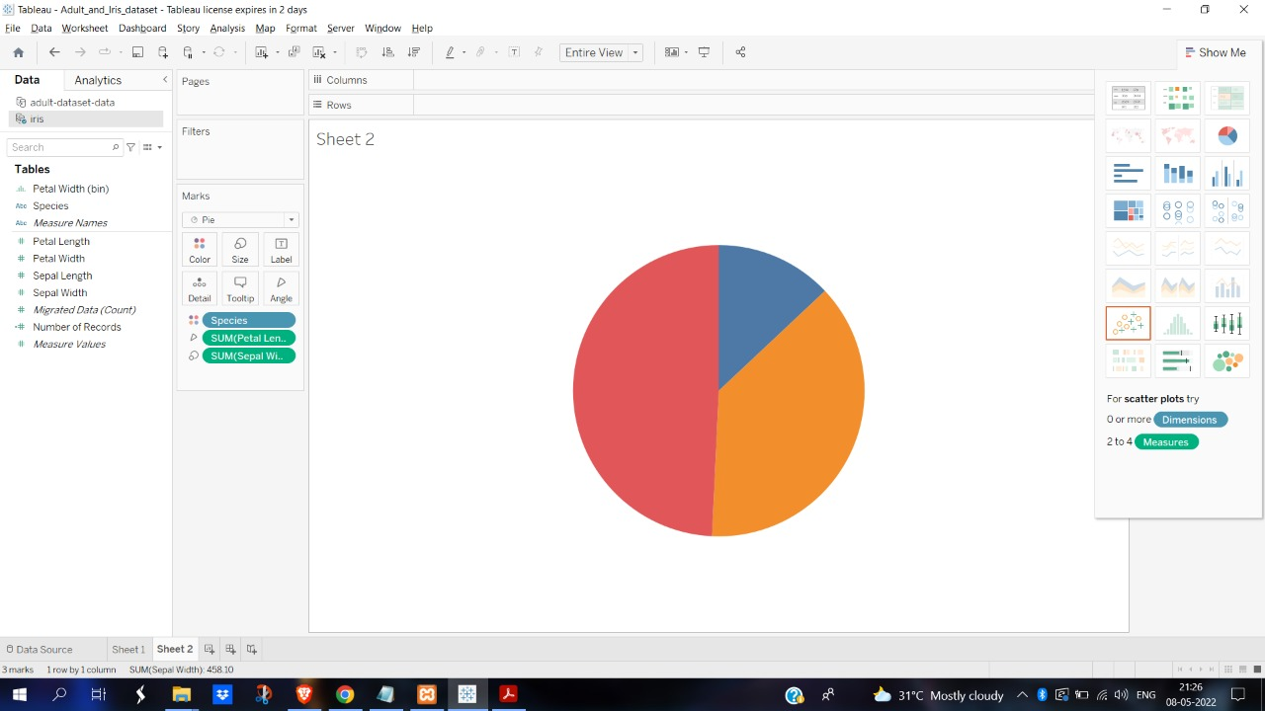

1. Tree/ Hierarchical Data visualization of Adult Dataset

